**AUTHENTICATION METHOD (SYSTEM MANAGED IDENTITY AND USER MANAGED IDENTITY)**

**So I already gave myself an in dentity in “Bcase-01-key valut” as Key vault system administrator but the problem here when I am selected System-Assigned Managed Identity (MSI) for authentication, but the secrets are not displaying when trying to create a Key Vault-linked service in ADF(bcase01-df) ; so now I am assigning a managed identity for data factory via Role assignment as follows:**

**How System-Assigned Managed Identity Works in ADF**

* **System-Assigned Managed Identity (MSI)** is a built-in Azure identity **tied to a resource**, in this case, **Azure Data Factory (ADF)**.
* When you select **System-Assigned Managed Identity** for ADF:
  + **ADF authenticates itself to Key Vault without needing a username/password.**
  + **Key Vault must explicitly allow ADF to access its secrets**.

**2️⃣ Why Are Secrets Not Displayed?**

The most common reason **secrets are not displayed** is because **ADF does not have permission to access Key Vault**. This can happen due to:

✅ **Missing Role Assignment in Key Vault (RBAC-based permissions)**

* Even though **you** are a "Key Vault Administrator," **ADF is not**.
* You must explicitly **assign ADF’s managed identity a role** in Key Vault.

✅ **No Access Policy (Old Access Control Method)**

* If your Key Vault is using **Access Policies** instead of Azure RBAC, you need to create an **Access Policy** for ADF and grant **"Get" and "List" secrets** permissions.

✅ **Different Regions for Key Vault and ADF (Less Common Issue)**

* ADF and Key Vault should be in the **same region** for seamless authentication.
* In your case, both **ADF (Bcase01-df) and Key Vault (bcase01-keyvault) are in Central US**, so this should not be a problem.

**3️⃣ How to Fix It (Step-by-Step)**

**Option 1: Use Azure RBAC (Recommended)**

1. **Go to Azure Portal** → **Key Vault (bcase01-keyvault)**.
2. In the left menu, select **Access Control (IAM)**.
3. Click **+ Add Role Assignment**.
4. Select the role: **Key Vault Secrets User**.
5. Click **Next** → **Assign Access to** → Select **Managed Identity**.
6. Under **Select Members** → **Choose your Data Factory (Bcase01-df)**.
7. Click **Review + Assign**.

Now, retry **testing the connection** in ADF.

**Option 2: Use Key Vault Access Policies (If Not Using RBAC)**

1. **Go to Azure Portal** → **Key Vault (bcase01-keyvault)**.
2. Select **Access Policies** from the left menu.
3. Click **+ Add Access Policy**.
4. Under **Secret Permissions**, select:
   * **Get**
   * **List**
5. Under **Select Principal**, search for **Bcase01-df (Your ADF Managed Identity)**.
6. Click **Add** → **Save**.

Now, go back to **ADF → Linked Service → Test Connection**.

**4️⃣ What Happens When We Assign an Authentication Method?**

When you select **System-Assigned Managed Identity**:

* **ADF requests access to Key Vault** using its own managed identity.
* If ADF **has the right permissions** (via **RBAC or Access Policies**), it can **retrieve secrets**.
* If permissions **are missing**, ADF **fails to get secrets**.

**✅ Summary**

* The issue happens because **ADF’s managed identity doesn’t have permission** to access Key Vault.
* **Fix it by either:**
  + Assigning **"Key Vault Secrets User"** role to ADF in **Access Control (IAM)** (RBAC method).
  + Adding ADF to **Key Vault Access Policies** with **Get & List** permissions (older method).
* Once access is granted, **ADF will be able to retrieve secrets** from Key Vault.

Here I am following option 1 :

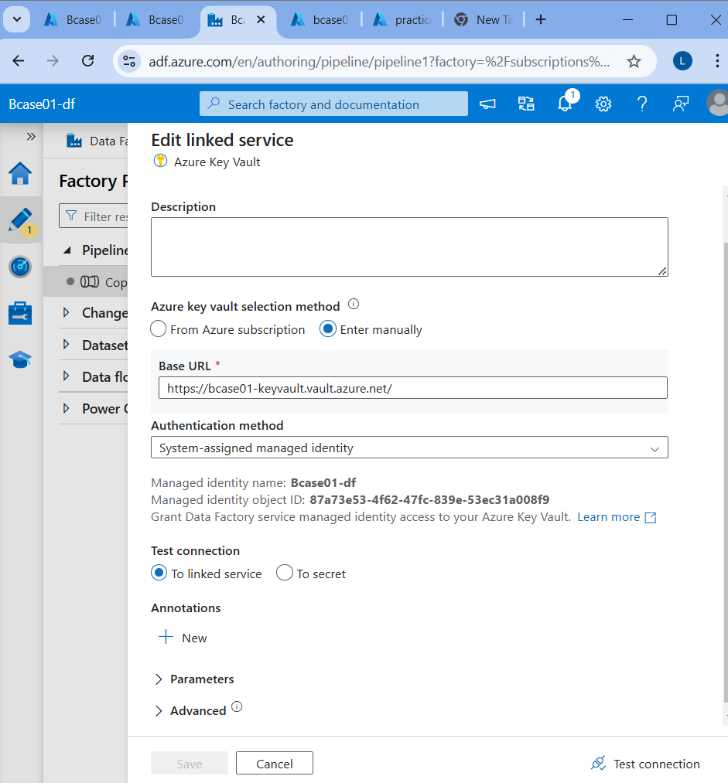

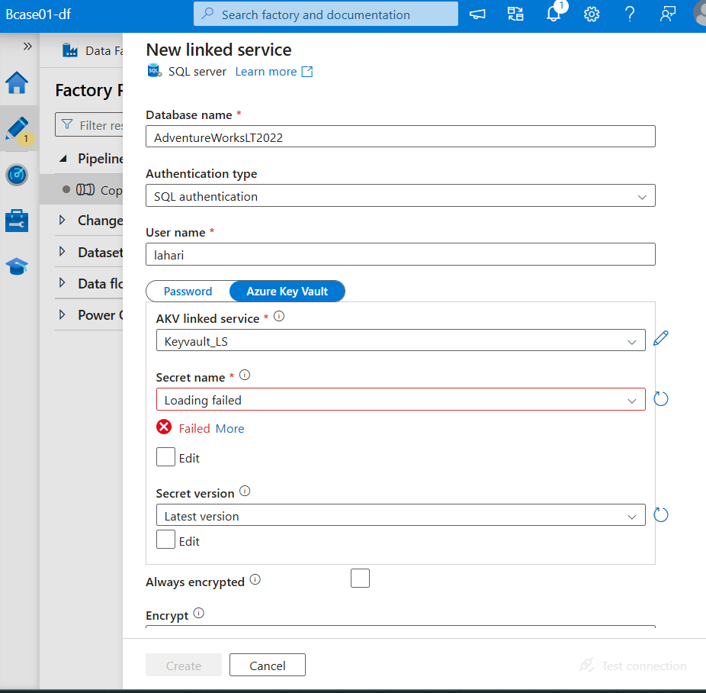

So here it is failed to access the secret names so I am assigning an identity for data factory so that It can access the key vault:

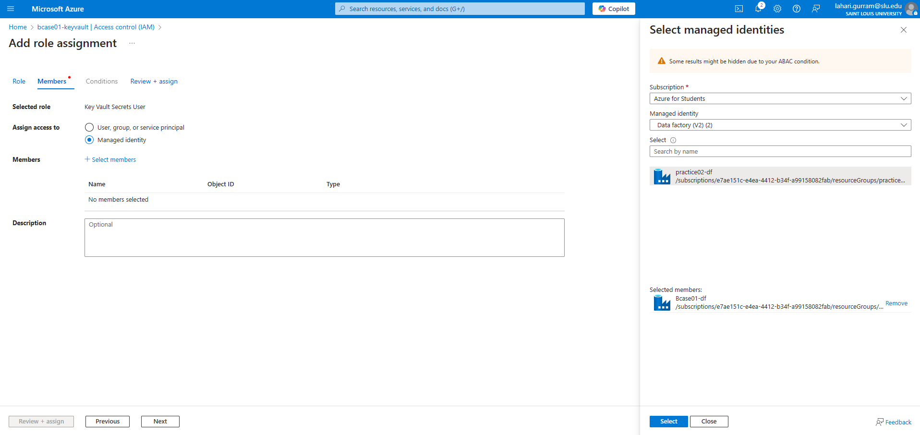

Here I assigned and created a permission for key vault and I will see if I can access the key vault: 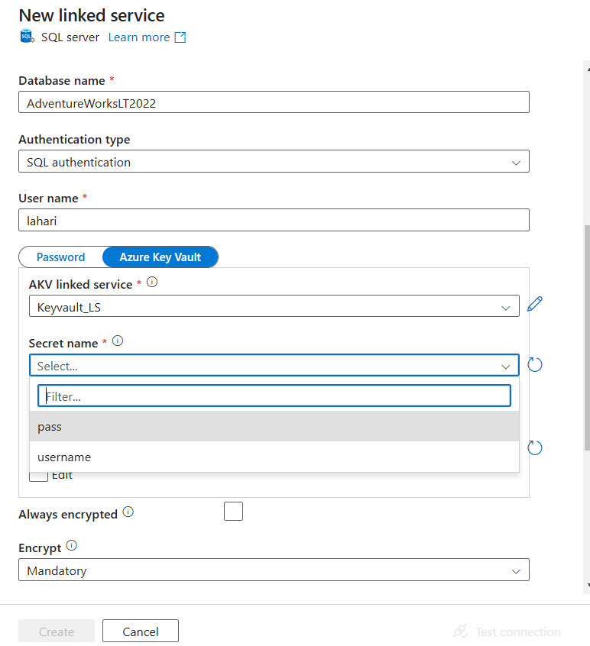

Here I can see that I can access the secrets after assigning key vault secret user role to ADF